Cross-Chain Bridge Settlement
# Source: AI Source: Provided by: [Data Path: Persons Table -> ID Column: 1, Name_En Column: Motasem Essam] -> From: [ChatGPT] on [1/21/2026]
Cross-chain bridge settlement refers to the process of transferring cryptocurrency assets from one blockchain to another using a bridge protocol. It enables settlement across multiple blockchain ecosystems, allowing users to move tokens and complete payments or swaps across chains like Ethereum, BNB Chain, Solana, and more.

🧠 Simple Definition
# Source: AI Source: Provided by: [Data Path: Persons Table -> ID Column: 1, Name_En Column: Motasem Essam] -> From: [ChatGPT] on [1/21/2026]
Cross-chain bridge settlement is when crypto transactions are settled by moving assets across different blockchains, often using wrapped tokens or locking and minting mechanisms.

🔗 How Cross-Chain Bridge Settlement Works
# Source: AI Source: Provided by: [Data Path: Persons Table -> ID Column: 1, Name_En Column: Motasem Essam] -> From: [ChatGPT] on [1/21/2026]
There are two primary technical models:

1. 🔒 Lock-and-Mint (Wrapped Assets)
# Source: AI Source: Provided by: [Data Path: Persons Table -> ID Column: 1, Name_En Column: Motasem Essam] -> From: [ChatGPT] on [1/21/2026]
- User sends Token A to a smart contract on Chain 1 (e.g., Ethereum).
- The bridge locks the asset in a vault.
- A wrapped version (e.g., wToken A) is minted on Chain 2 (e.g., BNB Chain).
- The user can now spend or use that token on Chain 2.

2. 🔄 Burn-and-Release
# Source: AI Source: Provided by: [Data Path: Persons Table -> ID Column: 1, Name_En Column: Motasem Essam] -> From: [ChatGPT] on [1/21/2026]
- When moving back to Chain 1, the wrapped token is burned on Chain 2.
- The bridge then releases the original token back to the user on Chain 1.

🌍 Popular Cross-Chain Bridges
# Source: AI Source: Provided by: [Data Path: Persons Table -> ID Column: 1, Name_En Column: Motasem Essam] -> From: [ChatGPT] on [1/21/2026]
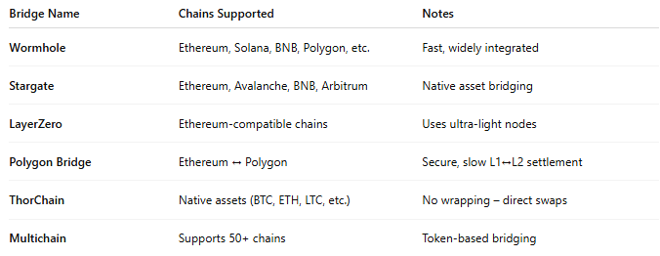

Bridge Name | Chains Supported | Notes
Wormhole | Ethereum, Solana, BNB, Polygon, etc. | Fast, widely integrated
Stargate | Ethereum, Avalanche, BNB, Arbitrum | Native asset bridging
LayerZero | Ethereum-compatible chains | Uses ultra-light nodes
Polygon Bridge | Ethereum ↔ Polygon | Secure, slow L1↔L2 settlement
ThorChain | Native assets (BTC, ETH, LTC, etc.) | No wrapping – direct swaps
Multichain | Supports 50+ chains | Token-based bridging

✅ Use Cases
# Source: AI Source: Provided by: [Data Path: Persons Table -> ID Column: 1, Name_En Column: Motasem Essam] -> From: [ChatGPT] on [1/21/2026]
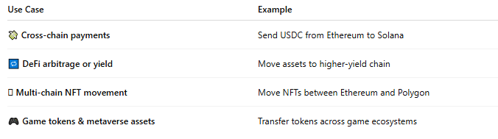

Use Case | Example
💸 Cross-chain payments | Send USDC from Ethereum to Solana
🔁 DeFi arbitrage or yield | Move assets to higher-yield chain
🪙 Multi-chain NFT movement | Move NFTs between Ethereum and Polygon
🎮 Game tokens & metaverse assets | Transfer tokens across game ecosystems

🧾 Benefits of Cross-Chain Settlement
# Source: AI Source: Provided by: [Data Path: Persons Table -> ID Column: 1, Name_En Column: Motasem Essam] -> From: [ChatGPT] on [1/21/2026]
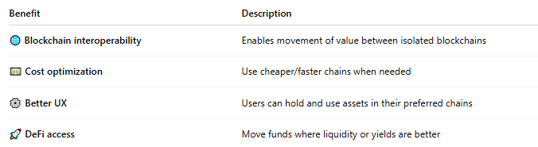

Benefit | Description
🌐 Blockchain interoperability | Enables movement of value between isolated blockchains
💵 Cost optimization | Use cheaper/faster chains when needed
⚙️ Better UX | Users can hold and use assets in their preferred chains
🚀 DeFi access | Move funds where liquidity or yields are better

⚠️ Risks & Limitations
# Source: AI Source: Provided by: [Data Path: Persons Table -> ID Column: 1, Name_En Column: Motasem Essam] -> From: [ChatGPT] on [1/21/2026]
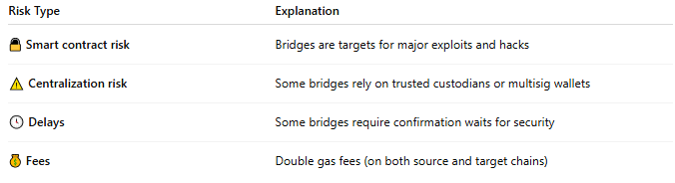

Risk Type | Explanation
🔓 Smart contract risk | Bridges are targets for major exploits and hacks
⚠️ Centralization risk | Some bridges rely on trusted custodians or multisig wallets
🕓 Delays | Some bridges require confirmation waits for security
💰 Fees | Double gas fees (on both source and target chains)
Example: Wormhole hack (2022) led to a $320M exploit due to bridge vulnerability.

🔐 Security Models
# Source: AI Source: Provided by: [Data Path: Persons Table -> ID Column: 1, Name_En Column: Motasem Essam] -> From: [ChatGPT] on [1/21/2026]
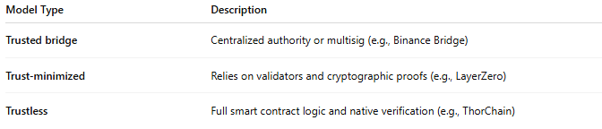

Model Type | Description
Trusted bridge | Centralized authority or multisig (e.g., Binance Bridge)
Trust-minimized | Relies on validators and cryptographic proofs (e.g., LayerZero)
Trustless | Full smart contract logic and native verification (e.g., ThorChain)

🧠 Summary
# Source: AI Source: Provided by: [Data Path: Persons Table -> ID Column: 1, Name_En Column: Motasem Essam] -> From: [ChatGPT] on [1/21/2026]
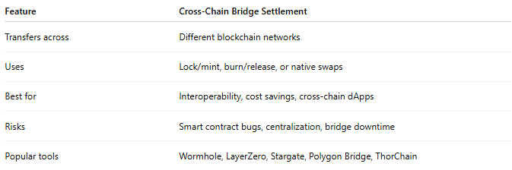

Feature | Cross-Chain Bridge Settlement
Transfers across | Different blockchain networks
Uses | Lock/mint, burn/release, or native swaps
Best for | Interoperability, cost savings, cross-chain dApps
Risks | Smart contract bugs, centralization, bridge downtime
Popular tools | Wormhole, LayerZero, Stargate, Polygon Bridge, ThorChain

